# Secondhand Car Sales System

## Case Study

A second-hand car sales system will be developed for web and mobile platforms. The primary purpose of this secondhand car sales system to be developed is to store and manage detailed information about the customer, car models, sales advertisements, and car owners. Car owners logging into the system with their name, surname, e-mail address, and password will be able to enter a new car advertisement on the system, view, edit, delete, and remove their existing advertisements. The owner of the car will enter and save the details of the announcement of the sales, such as the type of car, year of manufacture, brand, model, fuel type, engine, transmission, mileage, sales price, and car pictures. In addition, the car owner can add equipment such as fog lights, foldable mirrors, parking sensors, central locking, and a glass roof to their car. When the car owner adds a new listing or makes any changes to the listing, system administrators' approval will be required for the listing to be published. After the system administrators approve the announcement, the announcement will be published. Published ads will be displayed as shop window ads by customers who want to buy a car. Customers can examine the details of the cars they want to buy on the window advertisements. In addition, customers will be able to search for ads in detail by using information such as the type of car they want to buy, the year of manufacture, brand, model, fuel type, engine, transmission, mileage, and sales price. Through the system to be developed, customers can compare the car advertisements they are interested in. In addition, customers will be able to access the contact information of the car owners regarding the cars they are interested in, make comments, and express their opinions through the system. Apart from the transactions that car owners and customers can perform on the system, system administrators can enter and update information such as new car type, brand, model, and car hardware through the system management panel. The system, which will work on all web and mobile browsers, will support 5 million users simultaneously. Data belonging to customers and car owners will be secured using the MD5 encryption algorithm through the system with a strong database infrastructure. In the secondhand car sales system to be developed, advanced search algorithms will be used to ensure that the response time for any query will be less than 2 seconds. In addition, the system to be developed will be 100% secure against unauthorized user logins. The time that the car sales system to be developed will be closed due to routine maintenance will be at most 30 minutes in a one-month operating period.

## Functional Requirements

* System should store and manage detailed information about the customer, car models, sales advertisements, and car owners
* Car owners should be able to login to the system with their name, surname, e-mail address, and password
* Car owners should be able to enter a new car advertisement
* Car owners should be able to view, edit, delete, and remove their existing advertisements
* The owner of the car should be able to enter and save the details of the announcement of the sales, such as the type of car, year of manufacture, brand, model, fuel type, engine, transmission, mileage, sales price, and car pictures
* The car owner should be able to add equipment such as fog lights, foldable mirrors, parking sensors, central locking, and a glass roof to their car
* System must get the administrators’ approval to the listing, which the car owner adds a new listing or makes any changes to the listing
* The announcement must be published after the system administrators approve the announcement
* Published ads should be displayed as shop window ads by customers who want to buy a car
* Customers should be able to examine the details of the cars they want to buy on the window advertisements
* Customers should be able to search for ads in detail by using information such as the type of car they want to buy, the year of manufacture, brand, model, fuel type, engine, transmission, mileage, and sales price
* Customers should be able to compare the car advertisements they are interested in
* Customers should be able to access the contact information of the car owners regarding the cars they are interested in
* Customers should be able to make comments, and express their opinions through the system to the cars of the car owner
* Car owners and customers must be able to perform transactions on the system
* System administrators must be able to enter and update information such as new car type, brand, model, and car hardware through the system management panel

## Non-Functional Requirements

* The system should be able to work on all web and mobile browsers
* The system must be able to support 5 million users simultaneously
* Data belonging to customers and car owners will be secured using the MD5 encryption algorithm through the system with a strong database infrastructure
* In the secondhand car sales system to be developed, advanced search algorithms will be used to ensure that the response time for any query will be less than 2 seconds
* The system to be developed will be 100% secure against unauthorized user logins
* The time that the car sales system to be developed will be closed due to routine maintenance will be at most 30 minutes in a one-month operating period.

## Use case Diagram for Secondhand Car Sales System.

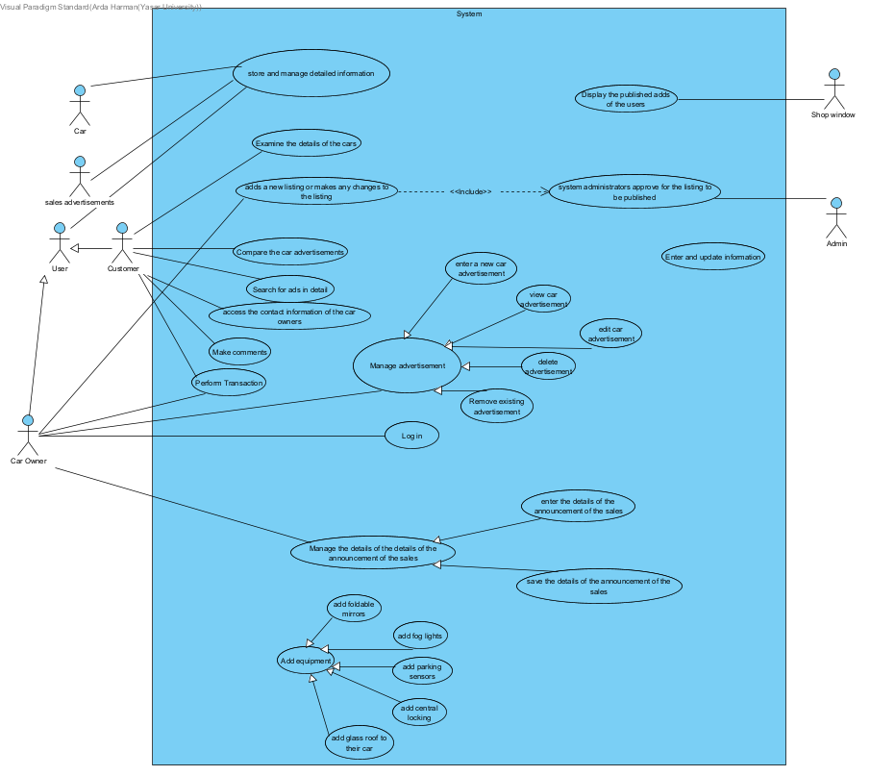

## Class Diagram for Secondhand Car Sales System.

## Sequence Diagram for Secondhand Car Sales System.

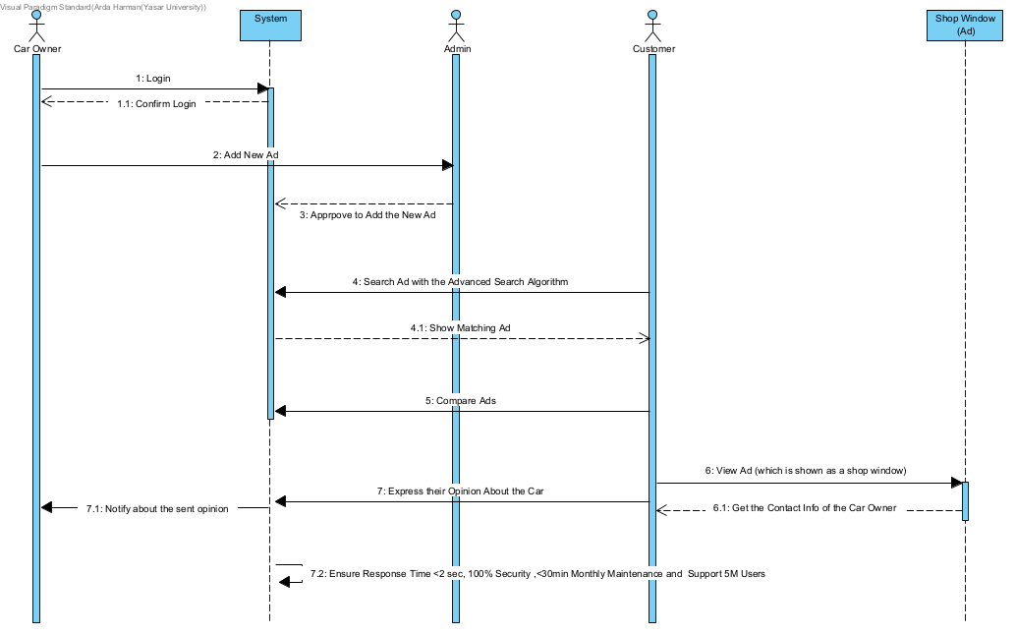

## Definitions of Use cases

Table 1 ____

|  |  |
| --- | --- |
| Use-case Name: | Secondhand Car Sales System |
| Brief description: | Customers are looking to ads for buying cars to car ads which car owners publish if the admin approves |
| Actor: | Car owner, Admin, customer |
| The flow of realization: | Car owners log into the system. After that, it makes a new ad to publish. Admin checks that ad and approves that and then the ad gets published. Customers search for that ad and selects an ad among the matching ads. At the ad, customers get the contact info of the car owner and makes a comment |
| Step-step Description: | 1. Car owner logs in to the system 2. Car owner publishes an ad 3. Admin control the ad 4. Admin approves the ad 5. Customer searches the ad 6. System gives the matching result 7. Customer selects an ad 8. Customer gets the contact info of the car owner 9. Customer makes a comment |

## Possible Scenarios

**Possible Scenario for Secondhand Car Sales System** **Use-case**

**1. Admin Approves Publishing Ad**

1. System receives a publishing request for an ad

2. System gives a notification to the admin

3. Admin checks if the ad is valid or not

4. Admin approves the ad

5. Ad gets published

**2. Logging in**

1. Car owner enters his/her account info

2. System checks whether there exist an account like that or not

3. (If exists) System validates the account

4. User successfully logs in to the account

**3. Creating Account**

1. Car owner enters his/her desired account info

2. System checks whether there exist an account like that or not

3. (If does not same account exists) System validates the account

4. User successfully creates their account

**4. Customer Contacts with Car Owner**

1. Customer searches the ad

2. System gives the matching ads

3. Customer selects an ad

4. Customer gets the contact info of the car owner

5. Customer calls the car owner and/or posts his/her comments about the car

**5. System ensures MD5 Encryption with the MD5 Encryption Algorithm**

1. User enter their data

2. The entered data of the users are fetched to the system

3. System gets the data

4. System reads the data

5. System uses the MD5 Encryptionalgorithm to the data

6. Data becomes encrypted

7. System makes a fetch request to the database to post the encrypted data

8. Database accepts the request

9. Database stores the encrypted data

**6. System uses Advanced Search Algorithm**

1. User enters text to the search bar as an input

2. System calls it’s Advanced Search Algorithm function which works with the entered input

3. System displays the matching results